**ABSTRACT**

**Introduction**

This project deals with the Corporate Medicare Management. This project is very helpful to both Medicare staff as well as to the public. It is having mainly Administration and Client modules.

The growing quality demand in the hospital sector makes it necessary to exploit the whole potential of stored data efficiently, not only the clinical data, in order to improve diagnoses and treatments, but also on management, in order to minimize costs and improve the care given to the patients.

This project adds the details of every individual patient and the staff appointed to them, it stores the schedule of doctors and their operation timings. It is a user friendly system which can be used by any person. It can also store the duration of a patient till the time of discharge. It helps in the satisfaction of the user and the public itself.

**Existing System Features**

1. Integration of Corporate Medicare centers is very difficult while it is having different branches.
2. In most of the cases the database is similar from one hospital to another hospital. In those cases also we can’t easily adapt a new technology in the new hospital.
3. It is very difficult to analyze the usage percentage of hospital resources, Bed occupation Ratio, Administration, Laboratory information even in a single center. Then we can expect the complexity while integrating multi-specialty Medicare Centers.
4. Room Reservations, Doctor Appointment Schedules, Operation Schedules, and Medicine indentation information is very difficult to maintain and share among the different Medicare Centers.

Lack of generic and unique model we have to implement the same set of data model for every newly established Medicare Center.

**PROPOSED SYSTEM**

In Medicare management situations we are dealing with Data Mining objectives such as:

1. To optimize bed occupation.
2. To improve the use of operating theatres, avoiding the cancellation of operations.
3. To know how emergencies affect to the administration of the hospital departments

or services (cancellation of operations, etc).

1. To detect the influence of certain diseases in the hospital’s services.
2. To find clusters of patients.

**Hardware & Software Requirement Specification**

OPERATING SYSTEM : WINDOWS 7 and more

SOFTWARE : NET BEAN 8.2

LANGUAGE : JAVA

PROCESSOR : Intel® Core (TM) i3 and more

PROCESSOR SPEED : 2.4GHZ

HARD DISK : 40GB

RAM : Minimum 2GB

DATA BASE : .DAT file

**Contents**

|  |  |  |
| --- | --- | --- |
| **S. NO** | **CONTENTS** | PAGE NO. |
|  | Introduction | 1 |
|  | Literature Survey | 2 |
|  | System Analysis | 4 |
|  | 3.1 Objectives | 4 |
|  | 3.2 Problem specification | 4 |
|  | 3.3 Proposed system | 5 |
|  | 3.4 Applications | 5 |
|  | 3.5 Modules and their functionalities | 6 |
|  | 3.6 Software and Hardware Requirements | 7 |
|  | Design | 8 |
|  | 4.1 Flow chart | 8 |
|  | 4.2 Algorithms | 9 |
|  | Implementation | 11 |
|  | 5.1. Partial code  5.2 Screen shots | 11  19 |
|  | Conclusion and Future Enhancement | 23 |

Chapter I: Introduction

This project deals with the Corporate Medicare Management. This project is very helpful to both Medicare staff as well as to the public. It is having mainly Administration and Client modules. The growing quality demand in the hospital sector makes it necessary to exploit the whole potential of stored data efficiently, not only the clinical data, in order to improve diagnoses and treatments, but also on management, in order to minimize costs and improve the care given to the patients.

It is a process of implementing all the activities of the hospital in a computerized automated way to fasten the performance. This project is to maintain the patient details, lab reports and to calculate the bill of the patient. You can also manually edit any patient details and issue bill receipt to patient within few seconds.

This project gives the procedural approach how a patient gets treatment, details about date of treatment and finally depending on different criteria like room allocated, lab reports, treatment and medicine take etc., how billing is calculated.

This project adds the details of every individual patient and the staff appointed to them, it stores the schedule of doctors and their operation timings. It is a user friendly system which can be used by any person. It can also store the duration of a patient till the time of discharge. It helps in the satisfaction of the user and the public itself.

**ChapterII: LITERATURESURVEY**

**Case 1:**

E Healthcare management is a growing profession with increasing opportunities in both direct and nondirect care settings. As defined by Buchbinder and Thompson (2010), direct care settings are those organizations that provide care directly to a patient, resident or client who seeks services from the organization.

**Disadvantage**:Existing system does not include Non-direct care settings. Non-direct care settings are not directly involved in providing care to persons needing healthservices, but rather support the care of individuals through products and services made available to direct care settings.

**Case 2:**

The construction of medical information is important to improve the hospital medical care capability, the management decision-making level of health and the hospital operational efficiency. Nowadays, comprehensive hospital information services and management platform have been established, centering on electronic medical records and clinical pathway.

**Disadvantage**: The establishment and use of these information systems played an important role in improving the degree of patient satisfaction, enhancing hospital efficiency and healthcare quality, protecting the safety of healthcare, and reducing healthcare costs which is not there in existing system.

**Case 3:**

E Healthcare Management System (computerized) is increasingly becoming an emerging tool in health care arena to efficiently enable delivery of high quality health services. These systems have large computerized data bases intended primarily for communication and storing health and administrative information. EHMS has different components and includes broad scope and level of systems from departmental.

**Disadvantage**: Previously the Data was handled manually using record,pen etc. That were difficult to handle physically as the burden on the user increases.

**Chapter III: SYSTEM ANALYSIS**

**3.1 Objectives:**

The main objective while implementing the project E-Health care management System was to minimize the work and at the same time increase the speed of the work done.

**3.2 Problem specification:**

 Hospitals currently use a manual system for the management and maintenance of critical information. The current system requires numerous paper forms, with data stores spread throughout the hospital management infrastructure. Often information is incomplete or does not follow management standards.

1. Integration of Corporate Medicare centers is very difficult while it is having different branches.
2. In most of the cases the database is similar from one hospital to another hospital. In those cases also we can’t easily adapt a new technology in the new hospital.
3. It is very difficult to analyze the usage percentage ofhospital resources, Bed occupation Ratio, Administration, Laboratory information even in a single center. Then we can expect the complexity while integrating multi-specialty Medicare Centers.
4. Room Reservations, Doctor Appointment Schedules, Operation Schedules, and Medicine indentation information is very difficult to maintain and share among the different Medicare Centers.
5. Lack of generic and unique model we have to implement the same set of data model for every newly established Medicare Center.

Forms are often lost in transit between departments requiring a comprehensive auditing process to ensure that no vital information is lost. Multiple copies of the same information exist in the hospital and may lead to inconsistencies in data in various data stores.

**3.3 PROPOSED SYSTEM**

The E-Health care ManagementSystem is designed for any hospital to replace their existing manual paper based system. The new system is to control the information of patients. Room availability, staff and operating room schedules and patient invoices. These services are to be provided in an efficient, cost effective manner, with the goal of reducing the time and resources currently required for such tasks.

In E-Health care Management System situations we are dealing with objectives such as:

1. To optimize bed occupation.
2. To improve the use of operating theatres, avoiding the cancellation of operations.
3. To know how emergencies affect to the administration of the hospital departmentsor services (cancellation of operations, etc.).
4. To detect the influence of certain diseases in the hospital’s services.
5. To find clusters of patients.
6. This system is mainly built for the purpose to reduce the work and improve the efficiency in the hospital’s management.
7. Recording information about the Patients that come.
8. Generating bills at any instance of time.
9. Recording information related to diagnosis given to Patients.
10. Keeping record of the Immunization provided to children/patients.
11. Keeping information about various diseases and medicines available to cure them.

These are the various jobs that need to be done in a Hospital by the operational staff and Doctors. The above facts, figures and drawbacks clearly indicate that there is need for computerization and thus decided to computerize the “E-Health care management system”.

3.4 Applications

* Consistent user interface with high economic features built into it.
* System design is modular and structured way so as to make the integration with other subsystems easier.
* User has complete control as it provides and accept only appropriate and valid data.
* User-friendly error messages are provided wherever necessary.
* Addition of new patient record, deletion of the existing record and modification of existing records as when needed.
* Provision of saving the info for new patient’s.
* Generate bills for the patients respectively.

3.5. Modules and their functionalities

**Patient module:-**

Patient’s personal information can be store by using this module. Details such as Patient ID,Name,Age, Sex, Address, Phone Number, gender can be saved using this module. It is used to store information about patients who were admitted in the hospital on doctor’s advice.

**History Module:-**

Here we can see previous or existing details of particular patient such as Patient ID, Dept depending on disease, Doctor, Ward, Date of admitted, Date of discharge.Updation like deletion and modification is done.

**Diagnosis module:-**

This module used to store or produce the laboratory reports. Patient ID, ward Category, Doctor, Date, Medicines or drugs.Updation like deletion and modification is done.

**Billing module:-**

This module works as its name itself says, to generate the bill of the patient with displaying the details such as Patient ID, doctor’s charge, health card amount, room bill, medicine bill, total amount, No of days, Service charge, Operation theatre charge, Nursing care, Lab bill.

**Information module:-**

This module gives information about the working of every module.

**3.6 Software and Hardware requirements**

### **Hardware Environment**

* The HDD required for the application is minimum 40GB.
* The application works on minimum Intel core i3.
* It requires 2GB RAM.

### **Software Environment**

* The application is designed using Net Bean IDE 8.2.
* The technology used is Java.
* The database has been designed on .DAT file.

**Chapter IV: DESIGN**

* 1. **Data Flow Chart**

START

Display the menu

Add the record of new patient

Input new filename

*Option = patient*

File exist

Input filename

Store the reports.

Option= Diagnosis

*No*

Display error message

Input Filename

Option=History

Display the history of patient

File Exist

File Exist

Input Filename

Option= Bill

*Yes*

Generate the Bill

Display error message

Option= Help

Display the uses of every option.

STOP

**4.2 Algorithm**

**Step 1:** Enter the correct password.

**Step 2:** Menu will be displayed choose the required optionyou want to perform.

**Step 3:** EnterOption1 i.e. the administration module which enables us to perform the following operation illustrate below:

1. Insert the patient information
2. Update the patient information
3. View the patient information
4. Delete the patient information

**Step 4:** If number of patient>=max patients the display patient can’t be added and return

If person is outpatient go to step 6 else step 5**.**

**Step 5:** option 2 provides us to store patient personal information here we need to enter the following details:

1. Name :
2. Age :
3. Sex:
4. Address:
5. Weight:

**Step 6** Now enter option 3 i.e outpatient module which take the information of the outpatient i.e illustrated below:

1. Enter the ID :
2. Enter the dept depending on the disease :
3. Room number:
4. Date of admitted date of discharge :

**Step 7:** Now press 4 to create patient report which ask us to

1. Enter patient ID number:
2. Enter Weight
3. Enter Name of Doctor appointed to
4. Date
5. Enter Precipitation to be followed.

**Step 8**: now enter 5 to generate bill of the patient,to generate bill

1. Enter the id number of patient
2. Name Doctor appointed to
3. Doctor fee
4. Health card number(not compulsory)
5. Room bill
6. Medicine bill
7. Lab bill
8. Operation theatre charges
9. Nursing bill

**Step 9 :** Now press enter which will display you the total cost you charged.

**Step 10** :Exit

**Chapter V: Implementation**

**5.1. Partial code**

import java.util.*;

import java.lang.String;

import java.io.*;

import java.time.format.DateTimeFormatter;

import java.time.LocalDateTime;

class Info

{

Info()

{

System.out.print("\t\t\t\t\t ___________________________________________________________________________________________\n");

System.out.print("\t\t\t\t\t| |\n");

System.out.print("\t\t\t\t\t| |\n");

System.out.print("\t\t\t\t\t| |\n");

System.out.print("\t\t\t\t\t| |\n");

System.out.print("\t\t\t\t\t| |\n");

System.out.print("\t\t\t\t\t| |\n");

System.out.print("\t\t\t\t\t| WELCOME TO E-HEALTH CARE MANAGEMENT SYSTEM |\n");

System.out.print("\t\t\t\t\t| |\n");

System.out.print("\t\t\t\t\t| |\n");

System.out.print("\t\t\t\t\t| |\n");

System.out.print("\t\t\t\t\t| |\n");

System.out.print("\t\t\t\t\t| |\n");

System.out.print("\t\t\t\t\t| |\n");

System.out.print("\t\t\t\t\t| -Brought To You by |\n");

System.out.print("\t\t\t\t\t| Mr Prabin Chaudhary |\n");

System.out.print("\t\t\t\t\t|___________________________________________________________________________________________|\n");

}

//Declaring variales to be used

Scanner scan=new Scanner(System.in);

String name;

String address;

long contact;

int age;

String bg;

String sex;

String disease;

long id;

String dadm;

//To take a pause

private void pressAnyKeyToContinue()

{

System.out.println("Press Enter key to continue...");

try

{

System.in.read();

}

catch(Exception e)

{

System.out.println("Press 'Enter' key to continue!");

}

}

//Taking multiple words

String readString()

{

Scanner scanner = new Scanner(System.in);

return scanner.nextLine();

}

//Log in Module

void login()

{

String pass;

int a;

System.out.print("\t\t\t\t\t _______________________________________________________________________________________ \n");

System.out.print("\n\t\t\t\t\t\t\t\tE-HEALTH CARE MANAGEMENT SYSTEM \n");

System.out.print("\t\t\t\t\t _______________________________________________________________________________________ \n");

System.out.println("\n\n\t\t\t\t\t\t\t\t------------------------------");

System.out.print("\n\t\t\t\t\t\t\t\t\t LOGIN \n");

System.out.print("\t\t\t\t\t\t\t\t------------------------------\n\n");

System.out.print("\t\t\t\t\t\t\t\tEnter the Password: ");

pass=scan.next();

if(pass.equals("Prabin"))

{

System.out.print("\n\n\t\t\t\t\t\t\t\tAccessGranted!\n");

pressAnyKeyToContinue();

}

else

{

System.out.print( "\n\n\t\t\t\t\t\t\t\tAccess Aborted...\n\t\t\t\t\t\t\t\t1.Try Again\n\n\t\t\t\t\t\t\t\t2.Exit");

System.out.print("\n\n\t\t\t\t\t\t\tEnter the option: ");

a=scan.nextInt();

if(a==1)

login();

else if(a==2)

System.exit(0);

else

{

System.out.print("\n\n\t\t\t\t\t\tInvalid Choice\n");

login();

}

}

}

//To get Date

public void getCurrentTimeUsingDate()

{

DateTimeFormatter dtf = DateTimeFormatter.ofPattern("yyyy/MM/dd HH:mm:ss");

LocalDateTime now = LocalDateTime.now();

dadm=dtf.format(now);

}

void menu()

{

int k;

//giving option to the user for their choice

System.out.print("\t\t\t\t\t _______________________________________________________________________________________ \n");

System.out.print("\n\n\t\t\t\t\t\t\t\t E-HEALTH CARE MANAGEMENT SYSTEM \n\n");

System.out.print("\t\t\t\t\t _______________________________________________________________________________________ \n");

System.out.print("\n\n\t\t\t\t\t\tPlease, Choose from the following Options: \n\n");

System.out.print("\t\t\t\t\t\t _________________________________________________________________ \n");

System.out.print("\t\t\t\t\t\t| |\n");

System.out.print("\t\t\t\t\t\t| 1 >> Add New Patient Record |\n");

System.out.print("\t\t\t\t\t\t| 2 >> Add Diagnosis Information |\n");

System.out.print("\t\t\t\t\t\t| 3 >> History of the Patient |\n");

System.out.print("\t\t\t\t\t\t| 4 >> Bill of the patient |\n");

System.out.print("\t\t\t\t\t\t| 5 >> Information About the Hospital |\n");

System.out.print("\t\t\t\t\t\t| 6 >> Exit |\n");

System.out.print("\t\t\t\t\t\t|_________________________________________________________________|\n\n");

System.out.print("\t\t\t\t\t\tEnter your choice: ");k=scan.nextInt();

if(k>6||k<1)

{

System.out.print("\n\n\t\t\t\t\t\tInvalid Choice\n");

System.out.print("\t\t\t\t\t\tTry again...........\n\n");

menu();

} //if inputed choice is other than given choice

switch(k)

{

case 1: patient();

break;

case 2: diagnos();

break;

case 3: history();

break;

case 4: bill();

break;

case 5: info();

break;

case 6: exit();

}

menu();

}

void patient()

{

System.out.print("Enter the patient's file name: ");

String fileName =scan.next();

getCurrentTimeUsingDate();

try {

// Assume default encoding.

FileWriterfileWriter = new FileWriter(fileName+".txt");

// Always wrap FileWriter in BufferedWriter.

BufferedWriterbufferedWriter = new BufferedWriter(fileWriter);

// Note that write() does not automatically

// append a newline character.

System.out.print("\n********************************************************************\n");

bufferedWriter.write("Date of admission: "+dadm);

bufferedWriter.newLine();

System.out.print("\nName : ");name=readString();bufferedWriter.write("Name : "+name);

bufferedWriter.newLine();

System.out.print("\nAddress : ");address=readString();bufferedWriter.write("Address : "+address);

bufferedWriter.newLine();

System.out.print("\nContactNumber : ");contact=scan.nextLong();bufferedWriter.write("Contact Number : "+contact);

bufferedWriter.newLine();

System.out.print("\nAge : ");age=scan.nextInt();bufferedWriter.write("Age : "+age);

bufferedWriter.newLine();

System.out.print("\nSex : ");sex=scan.next();bufferedWriter.write("Sex : "+sex);

bufferedWriter.newLine();

System.out.print("\nBloodGroup : ");bg=scan.next();bufferedWriter.write("Blood Group : "+bg);

bufferedWriter.newLine();

System.out.print("\nAny Major disease suffered earlier : ");disease=readString();bufferedWriter.write("Any Major disease suffered earlier : "+disease);

bufferedWriter.newLine();

System.out.print("\nPatientID : ");id=scan.nextLong();bufferedWriter.write("Patient ID : "+id);

bufferedWriter.newLine();

System.out.print("\n********************************************************************\n");

bufferedWriter.write("\n********************************************************************\n\n");

bufferedWriter.newLine();System.out.print("\nInformation Saved Successfully\n");

**5.2.Screen shots**

**1.Login menu**

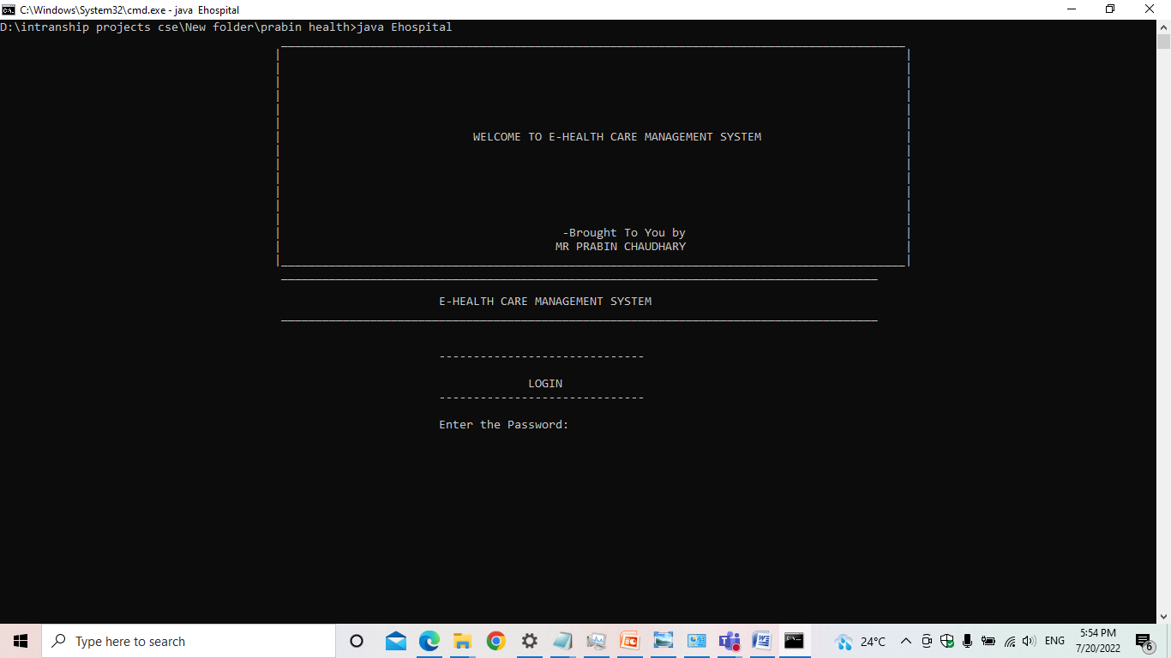

**2.Main menu**

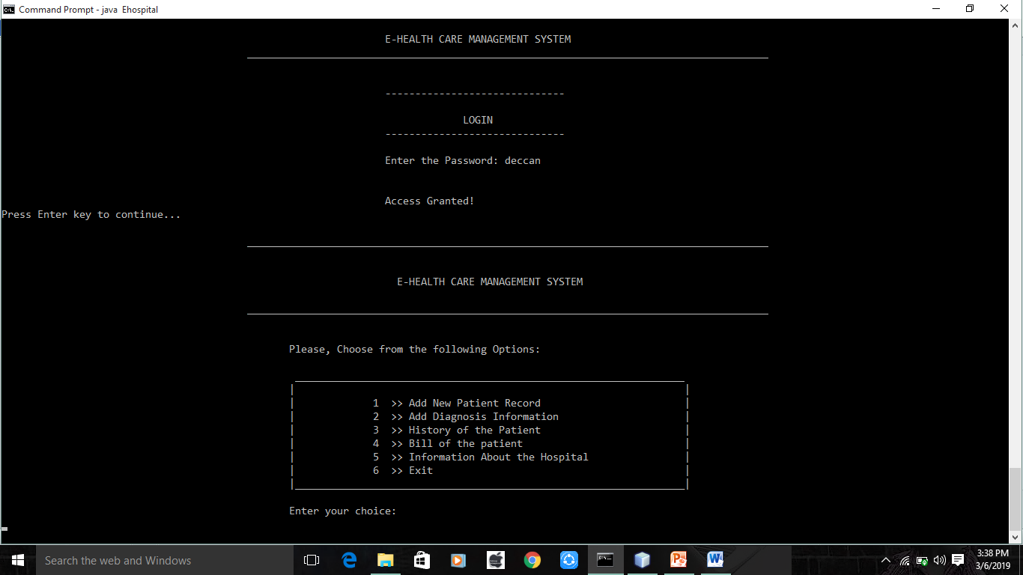

**3.Adding patient record**

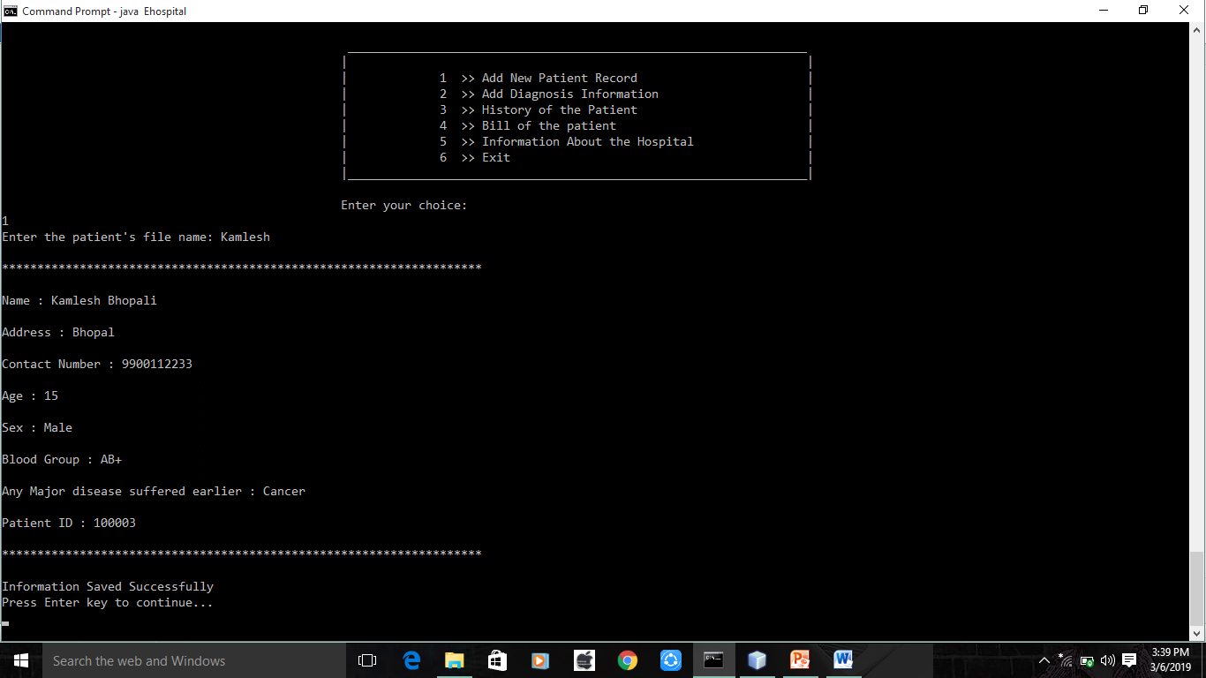

**4.Adding Diagnosis report**

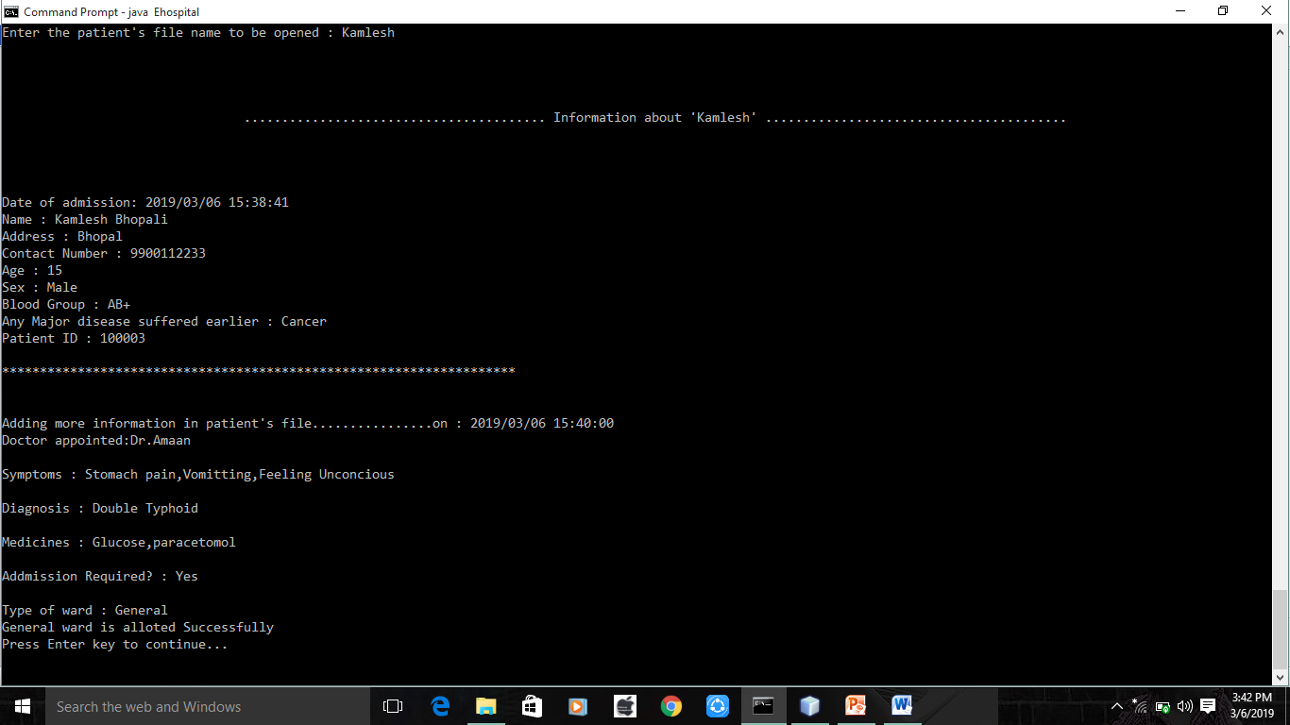

**5. History of the Patient**

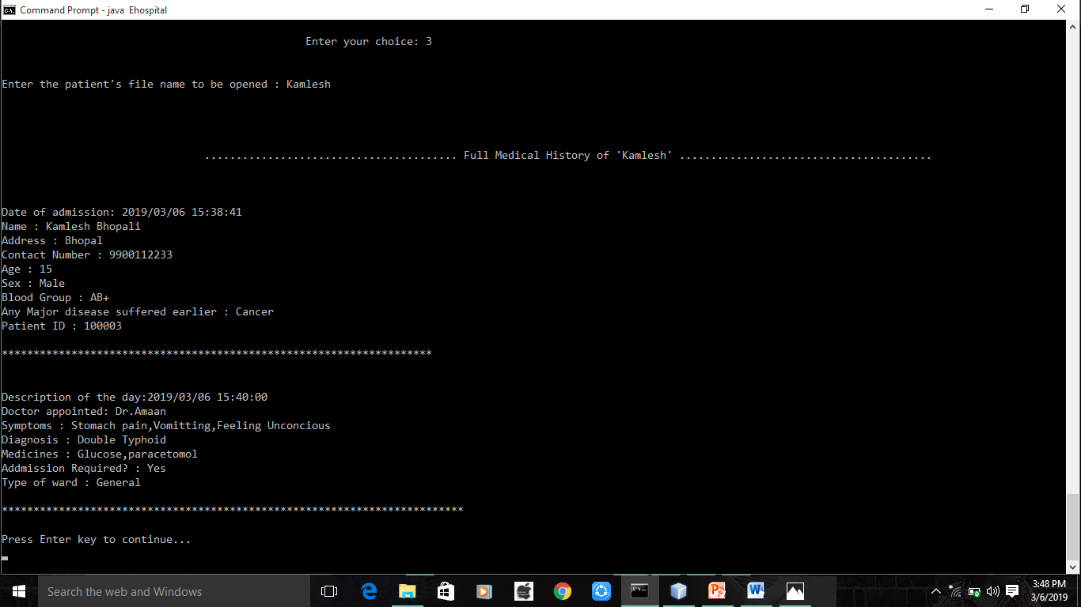

**6. Generate Bill**

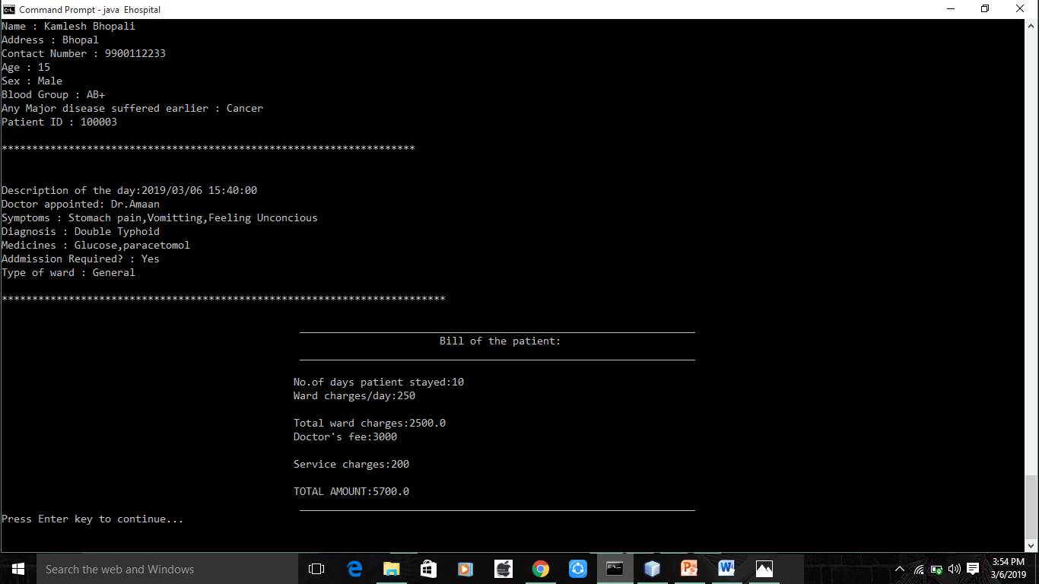

**7. Help**

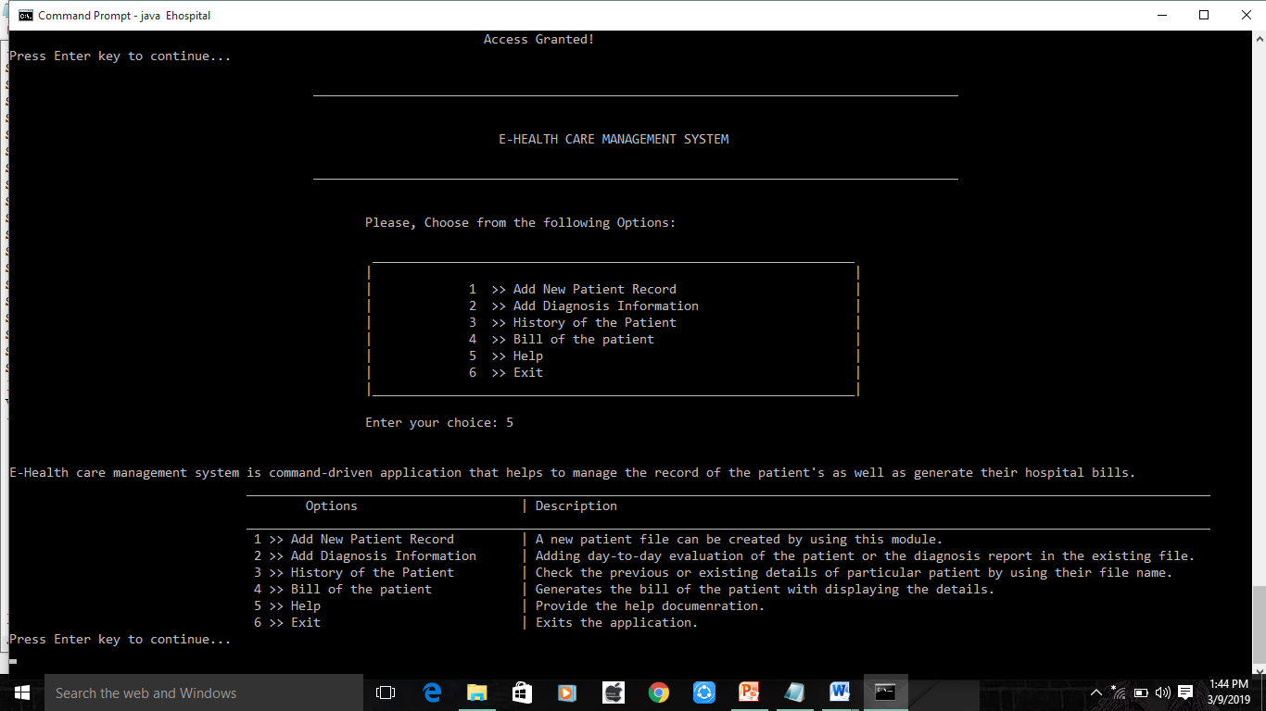

**8. Exit**

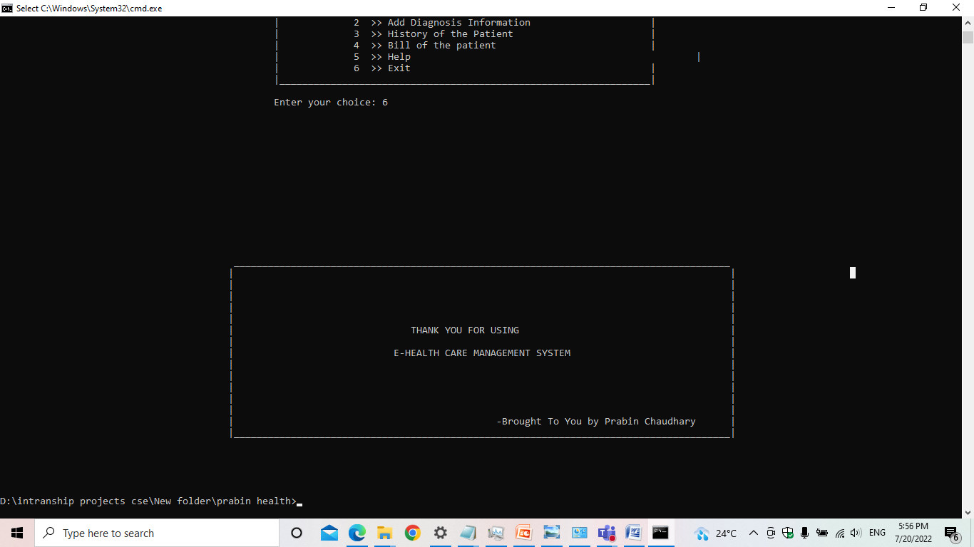

**Chapter VI: Conclusion and Future enhancement**

**Conclusion**

* A fully menu driven user-friendly computerized system has been developed where the user can perform task like entering data and appending the information with great ease.
* All the operations are carried automatically preventing a lot of manual work.
* Additional checks have also been incorporated into the system to avoid duplications of data as far as possible.

**Future Enhancement**

Every project whether large or small has some limitations no matter however diligently developed. In some cases limitations is small while in other cases they may be broad also. The new system has got some limitations. Major areas where modifications can be done are as follows:

* Our system is not online so further it can be improved.
* The security is limited so some additional arrangement could be made to provide more security to the system.